Lumkikhaya Luzuko Nonyongo
ST10512732@RCCONNECT.EDU.ZA
WEBSITE PROPOSAL

WEBSITE PROJECT PROPOSAL: THE SOPRANOS
1. Organisation Overview
- Name: The Sopranos Restaurant & Lounge
- Address: 3 Potassium Avenue, Cresswell, Roodepoort, 1724
- Brief History: Founded as a vibey local dining and nightlife establishment in northern Roodepoort, The Sopranos established itself as a vibrant bar and restaurant offering quality meals, drinks, and a social environment designed for relaxing and celebrating life and more
- Mission Statement: To deliver high-quality meals, exceptional customer service, and a welcoming, high-energy atmosphere where friends, young professionals, and locals can connect and celebrate life’s moments.
- Vision Statement: To become the most recognised and sought-after local dining and nightlife spot in northern Roodepoort through outstanding food, memorable customer experiences, and community engagement along with the exceptional vibe that comes with the night life in Mzansi
- Target Audience: Young professionals, university students, social groups, and local residents looking for dining, entertainment, and a lively social scene.
2. Website Goals and Objectives
- Specific Goals:
  - Brand Awareness & Visibility: Establish an official online hub to showcase the brand, ambiance, menu, and weekly events.
  - Direct Reservations & Enquiries: Allow customers to reserve tables online and submit general or private event inquiries directly.
  - Online Engagement: Provide interactive features such as updated digital menus, promotional offers, location maps, and direct contact options.
- Key Performance Indicators (KPIs):
  - Monthly event attendees depending on the event.
  - Number of completed online table reservations.
  - Number of contact form submissions and event enquiries.
  - Engagement metrics: Average session duration and bounce rate.
3. Current Website Analysis
- Strengths of Existing Presence:
  - Active social media footprint (Instagram, Facebook) providing organic customer reach and visual appeal.
- Weaknesses:
  - Limited to none information structure about the place or what its offering.
  - No automation of repetitive tasks and frequently asked questions .
- Areas for Improvement:
  - Development of a dedicated, branded website to centralized operations.
  - Streamlining customer conversions via direct online reservation forms and clear, structured contact channels.
4. Proposed Website Features and Functionality
- Core Pages:
  - Homepage: Dynamic hero banner showcasing the atmosphere, quick navigation, featured weekly specials, and direct call-to-action (CTA) buttons for booking.
  - About Us: History, mission, vision, and team/ambiance highlights.
  - Menu: Interactive digital menu categorized by food, signature cocktails, and beverages.
  - Reservations & Contact: Embedded online reservation form, interactive Google Maps location, opening hours, and direct contact information.
- Desired Functionality:
  - Mobile-responsive layout optimized for smartphones.
  - Embedded booking system or interactive enquiry form.
  - Social media integration (live Instagram feed/links).
  - Responsive web design adapting layouts ensuring diverse functionality across hardware
5. Design and User Experience (UX)
- Design Aesthetic:
  - The proposed website will adopt a high-energy, immersive, and sleek "Night Mode" aesthetic, mirroring the physical atmosphere of The Sopranos.
  - The focus will be on high-contrast visuals, using professional photography of the illuminated neon sign and the vibrant interior (images that match the look of the physical location) to create immediate brand recognition.
  - Typography will be clean and impactful, referencing the energy of the sign without compromising readability.
- Colour Palette:
  - The chosen colour scheme is derived directly from the physical branding and environment of the restaurant:
    - Primary Colour: Neon Crimson (#BF1E2E)
      - Role: Used sparingly for key elements like primary "Book Now" buttons, menu item categories, and important titles to emulate the vibrant energy of the illuminated sign.
    - Background Base: Deep Night Sky (#08080C)
      - Role: A near-black, sophisticated base for all background areas, allowing text and visuals to pop with maximum contrast, just as the physical sign does against the dark sky.
    - Secondary Accent: Warm Amber (#FFB81C)
      - Role: Used for highlights and subtle borders to reflect the welcoming glow of the string/fairy lighting visible in the physical patio area.
    - Body Text: Cold White (#F0F0F0)
      - Role: Ensuring crystal-clear readability and a modern, sleek contrast against the dark background.
6. Technical Requirements
- Domain & Hosting:
  - Domain: www.thesopranosroodepoort.co.za (or similar regional domain).
  - Hosting: High-speed cloud web hosting with SSL certificate (HTTPS) security.
- Languages & Frameworks:
  - Frontend: HTML5, CSS3 (or Bootstrap/Tailwind CSS), and JavaScript.
  - Version Control: Git & GitHub for source control and collaboration.
7. Timeline and Milestones
Phase | Milestone / Task | Target Duration
Phase 1 | Requirement Gathering, Proposal & Wireframing | Week 1-4
Phase 2 | UI/UX Design & Brand Asset Integration | Week 4-7
Phase 3 | Frontend Development (HTML/CSS/JS Layouts) | Week 7-9
Phase 4 | Testing, Responsiveness & Bug Fixes | Week 9-12
Phase 5 | Deployment & Final Submission / Launch | Week 12-15
8. Budget
Note: Figures reflect realistic market rates for a small-to-medium business web project.
- Website Design & Development: R12,500 (One-off)
- Domain Registration (.co.za): R150 (Annual)
- Web Hosting & SSL Security: R1,800 (R150/month, annual estimate)
- Maintenance & Technical Support: R3,600 (R300/month, annual estimate)
- Total Estimated Initial Project Cost: R18,050
9. References
- Google Maps. (2026). Location Details for 3 Potassium Ave, Creswell, Roodepoort, 1724.
- The Sopranos Restaurant & Lounge. (2026). Social Media Pages (Instagram & Facebook).
- W3C Web Content Accessibility Guidelines (WCAG 2.1).
- 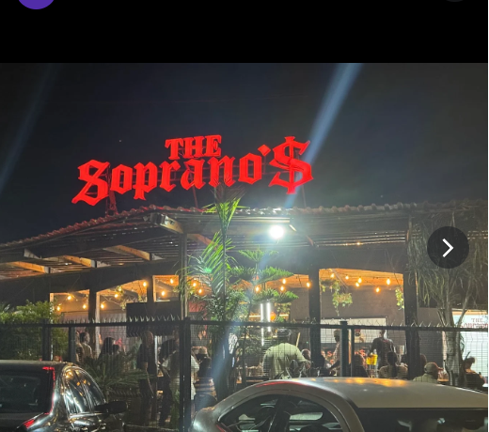
Wireframe
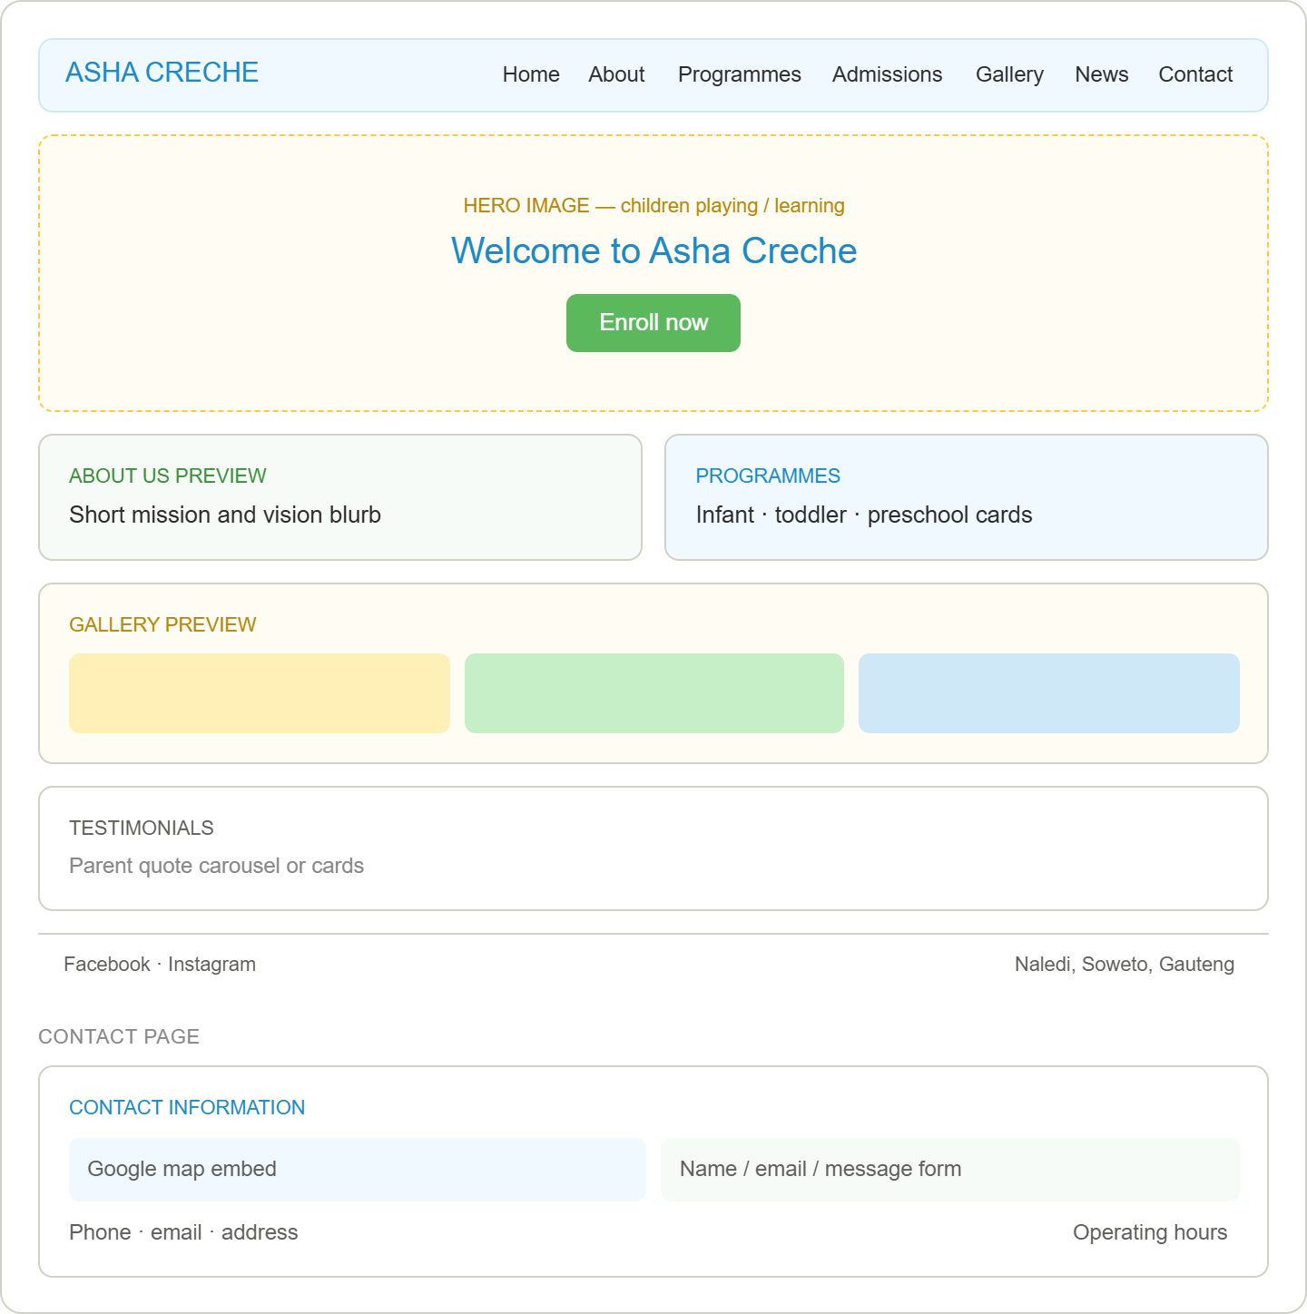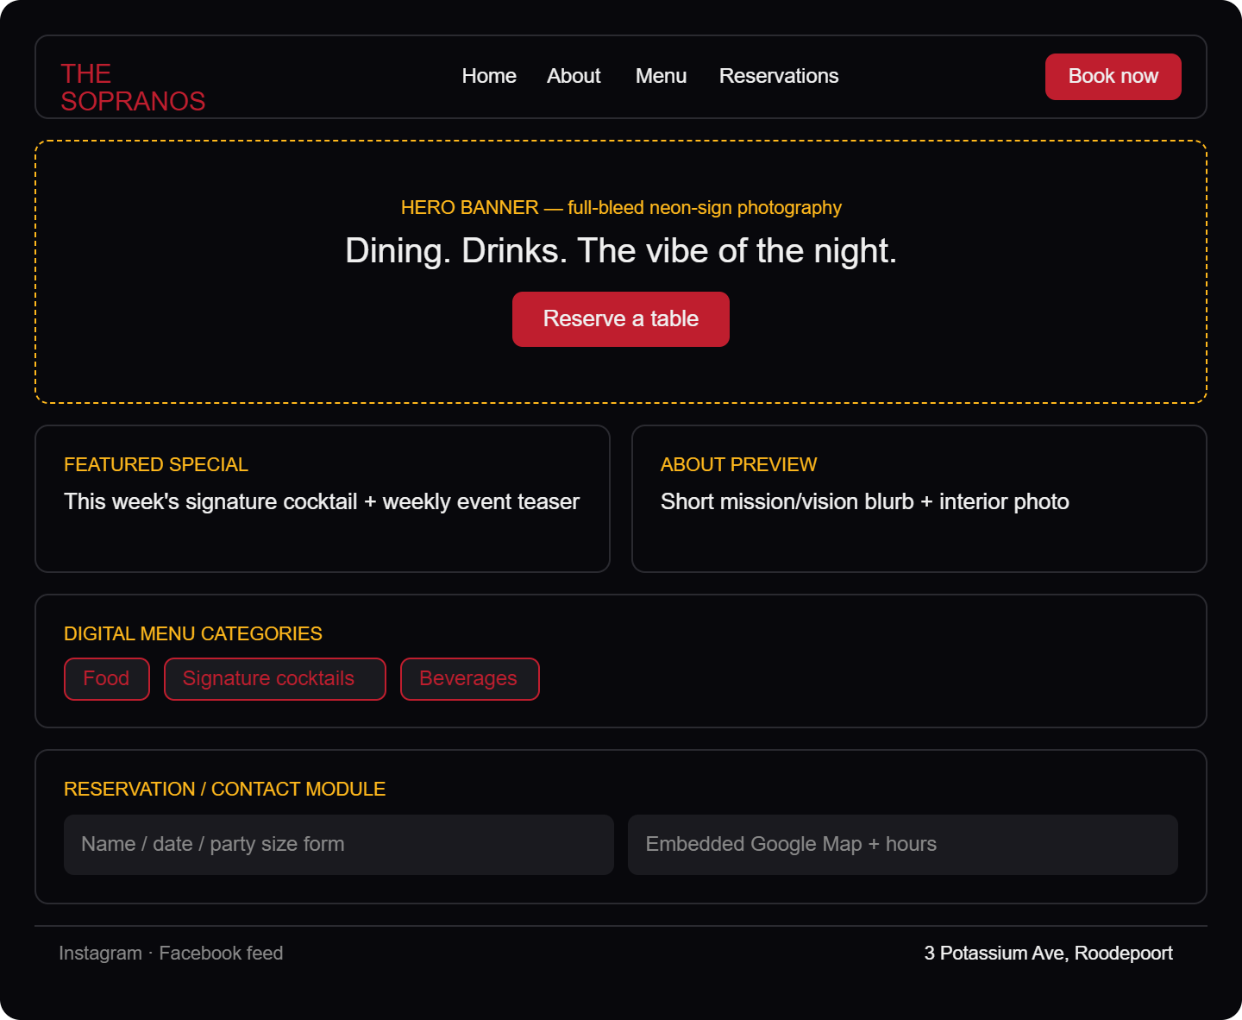
Second proposal

Website Project Proposal
Asha Creche (Daycare Centre)
1. Organisation Overview
Organisation Name: Asha Creche
Background
Asha Creche is a daycare and early childhood development centre located in Naledi, Soweto, Gauteng, South Africa. The centre provides a safe, caring, and educational environment for infants and young children while their parents or guardians are at work. The daycare focuses on children's physical, emotional, social, and cognitive development through structured learning activities and play.
Mission Statement
To provide quality early childhood education and childcare in a safe, loving, and stimulating environment that supports every child's growth and development.
Vision Statement
To become one of the leading early childhood development centres in Soweto by providing affordable, high-quality childcare and preparing children for future academic success.
Target Audience
• Parents looking for reliable childcare
• Guardians of children aged 3 months to 5 years
• Families living in Soweto and surrounding areas
• Community members seeking information about the daycare
________________________________________
2. Website Goals and Objectives
The primary goal is to create a modern, user-friendly website that helps parents easily access information about the daycare.
Objectives
• Increase awareness of Asha Creche within the local community.
• Provide information about childcare services.
• Display admission requirements.
• Allow parents to contact the daycare online.
• Showcase the learning environment through photographs.
• Share announcements and events.
• Improve communication with parents.
Key Performance Indicators (KPIs)
• Increase website visitors.
• More online enquiries through the contact form.
• Increase enrolment applications.
• Lower number of phone enquiries for basic information.
• Positive user feedback.
________________________________________
3. Current Website Analysis
Currently, Asha Creche does not have a professional website. Most information is only available through Google listings and social media.
Strengths
• Easy to find on Google.
• Existing contact information.
• Positive customer reviews.
Weaknesses
• No official website.
• Limited information available online.
• No online registration.
• No gallery showcasing facilities.
• No downloadable admission forms.
Opportunities
Creating a professional website will:
• Improve online visibility.
• Build trust with parents.
• Make communication easier.
• Increase enrolments.
• Provide information 24/7.
• Aswell as extend opportunities for internships for persons who have qualified to handle children
________________________________________
4. Proposed Website Features and Functionality
The proposed website will include the following pages:
Home
• Welcome message
• Hero image
• Short introduction
• Call-to-action button ("Enroll Now")
About Us
• History
• Mission
• Vision
• Staff introduction
Programmes
Information on:
• Infant care
• Toddler care
• Preschool programme
• Daily activities
Admissions
• Registration process
• Required documents
• Fees (optional if approved)
• Downloadable application form
Gallery
• Classroom photos
• Outdoor play area
• Learning activities
• Events
News & Events
• Holiday programmes
• Parent meetings
• School events
• Announcements
Contact Us
• Google Map
• Address
• Phone number
• Email
• Contact form
• Operating hours
________________________________________
5. Design and User Experience
Colour Scheme
The website will use bright and welcoming colours that appeal to families.
Primary Colours:
• Sky Blue
• Green
• Yellow
• White
These colours represent:
• Trust
• Growth
• Learning
• Happiness
Typography
Headings
• Poppins Bold
Body Text
• Open Sans
Layout
The website will have:
• Responsive design
• Simple navigation
• Large images
• Clear buttons
• Mobile-friendly layout
• Fast loading pages
User Experience Considerations
• Easy navigation
• Accessible fonts
• High colour contrast
• Contact information visible on every page
• Mobile responsiveness
• Fast page loading
________________________________________
Low-Fidelity Wireframes
Home Page
-------------------------------------------------
Logo Navigation Menu

Hero Image

Welcome to Asha Creche

[Enroll Now]

About Us Preview

Programmes

Gallery Preview

Testimonials

Footer
-------------------------------------------------
Contact Page
-----------------------------------
Contact Information

Google Map

Contact Form

Operating Hours

Footer
-----------------------------------
________________________________________
6. Technical Requirements
Front-end
• HTML5
• CSS3
• JavaScript
Framework (optional)
• Bootstrap 5
Back-end (future enhancement)
• PHP
• MySQL
Hosting Requirements
• Domain name
• Web hosting
• SSL Certificate
Browser Support
• Chrome
• Edge
• Firefox
• Safari
________________________________________
7. Timeline and Milestones
Week Activity
Week 1-4 Research and Proposal
Week 4-7 Wireframes and Planning
Week 7-9 Website Design
Week 9-12 HTML Development
Week CSS Styling
Week JavaScript Functionality
Week Testing and Bug Fixes
Week 12-15 Final Submission
________________________________________
8. Budget (Estimated)
Item Estimated Cost (ZAR)
Domain Registration (.co.za) R150/year
Web Hosting R1,200/year
SSL Certificate Free (Let's Encrypt)
Website Design R4,000
Website Development R8,000
Testing R1,000
Maintenance (Annual) R2,500
Total Estimated Cost R16,850
(Since this is an academic assignment, these are realistic estimates and can be adjusted if your lecturer provides different guidelines.)
________________________________________
9. References
Use APA 7th edition formatting. Example references include:
• Asha Braamfischer. (n.d.). Asha Preschool. https://ashabraamfischer.com
• Google Maps. (n.d.). Asha Creche, Naledi, Soweto. https://maps.google.com
• Department of Basic Education. (2021). National Curriculum Framework for Children from Birth to Four. https://www.education.gov.za

